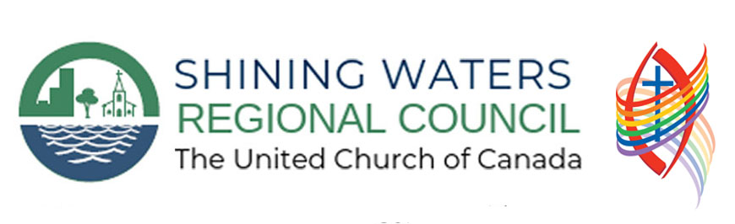
Prayers and Worship Resources in Times of Public Health Concern:
COVID-19/Coronavirus

Introduction

During times of Public Health crisis, we can often feel as though we are not sure what our place is in the community. We question what ministry personnel can do to help make a difference. We invite you to think about the space in which we worship each Sunday and the word ‘sanctuary’. The notion of sanctuary is that it be a place set apart for holy purposes, and each time we worship we are trying to create a holy space.

Below are prayers that have been crafted during this time of world-wide public health crisis. Please feel free to adapt these prayers, or use them as inspiration to create your own, they are here for you. As communities of faith, we will be navigating new territory of how to worship together in new and different ways. While also learning about how to understand our place in community with one another in new and different ways.

Know that in this time, as A New Creed states, “We Are Not Alone. Thanks Be To God.”

Two Prayers

A General Prayer

God of all who struggle in silence and isolation,
Provide us with the peace and strength in this time of need. As the world faces uncertainty and searches for answers about coronavirus, be there with us. Be there to shelter the most vulnerable as they worry and wonder. Be there in the hospital wards, emergency rooms, nursing homes, shelters, alleys, homes and all places where people seek shelter. Provide us with the wisdom and presence of mind to ensure that while we are in times of social distancing finding ways of connecting and being in community with those we love.
Amen

For When A Community Is Not Gathering In Person.

God, who brings down the walls that divide us, be with us as we work to understand new ways of being your people. Although we may not physically be together, because of reasons of public safety, help us to know that we are together emotionally and spiritually. For we all come to this place to lift up our prayers of hope, of love and of community. While we are apart from one another, let us remind ourselves that we are together in the sheltering arms and wings of the spirit that moves amongst and dwells within our very souls. Help us to find new ways of connecting with our neighbours, friends and family, and help us to know that even when we feel as though we are completely alone, we are not – we are always together.
Amen

While crafting prayer within your local context, there are those that you will be mentioning, and others might need to be included, they may include:

Public Health:
Hospitals, nursing homes, and other health care facilities
The World Health Organization
Medical researchers, scientists, and those working to produce testing kits
School Systems:
The students that are left out of class, wondering
Teachers that are learning how to navigate new systems of learning.
Administrators, making tough choices
Work places
Workers who are now being laid off, and worried about the costs of living
Workers who are anxious about safety of going to work where the building is not closed.
People working in high risk spaces, for minimum wages such as: grocery stores,

Government Institutions and Municipal Agencies
Guidance in decision making
Hope in the possibility that the right people will receive the funds needed
Those Living on the Margins
People in shelters, who are unable to stay in spaces of warmth
Foodbanks, where they are working to support those in need
Elderly, that are experiencing a new form of social isolation
People living with Mental Health Wellness struggles or Illness, as they lack programs, and community engagement.
The underpaid and the now-unemployed workers who are living paycheque to paycheque.

In These Times

Creator,
In Times of Distress,
We look for your face, and wonder.
In Times of Crisis,
We call out for your voice, and pray.
In Times of Civil Authority,
We wait for your hand, as a gentle reminder.
In Times of Neglect,
We shiver at the thought, and speak.
In Times of Affliction,
We cry in silence, and pound our fists.
In Times of Social Isolation,
We seek out community, and crave it.
In Times of Supporting,
We wait for possibility, for it will come again.
Amen

Scriptural Considerations

March 29th, 2020
Ezekiel, Psalm 130, John 11: 1-45

Reflection
When God calls on Ezekiel to prophesy the breath, he is encouraging Ezekiel to give new life to remains that were already thought to be dead. Think on these past weeks, as the numbers of those become infected with COVID-19 seem to be rising and rising, and think on what we as a people of faith may prophesy on. We may reflect on how much misinformation exists about our public health system, and how tirelessly people in health care and social care settings are working.

It is why when Ezekiel is doubtful God ends up letting Ezekiel take the lead, God is letting Ezekiel see the power that we as people hold to bring about change, and change for the better.

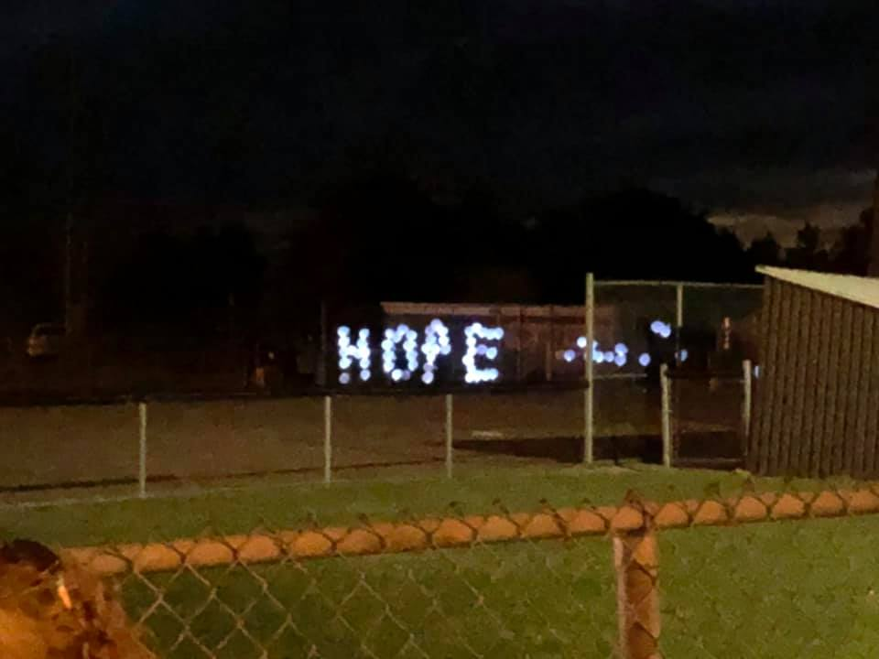
More Voices, Oh A Song Must Rise is included in today’s hymn selections, which may seem like an interesting choice to say the least, given the subject matter, but there is one particular moment in this hymn that all worship leaders may identify with, and that is in the part where we sing, “Sing out God’s praises and glory, the faithful voices blend”, and how in between “God’s” and “praises” there is a quarter rest, and with out fail, many – if not all of us – have encountered communities of faith that sing right through that rest. Grapping with why the composer put the rest in that exact spot can be time consuming and unproductive. Instead, consider the rest as a metaphor, as we struggle in these times we have to take moments of pause. Yes, we will be once again soon, singing out our praises and glories to God and all of creation, but for now, we are in a moment of pause. If you choose to use this hymn this Sunday, remind yourself and your community that this time of healing, and anxiety is also a time of pause in this world. Pauses help us to recognize just how interconnected we all are.

Hymns
We Have Come When Jesus Wept, 146 VU
Breathe On Me Breath of God, 382 VU
Oh A Song Must Rise, 142 MV

A Prayer
God who defies our time and space,
Be with us,
In the moments of reflective pause,
In the seconds of hopefulness,
In the hours of waiting.
Let us know that we are on a Lenten journey together,
Disrupted, but always together.
Amen.

April 5th, 2020
Palm Sunday – Matthew 21:1-11, Isaiah 50:4-9a, Phillipians 2:5-11

A Reflection
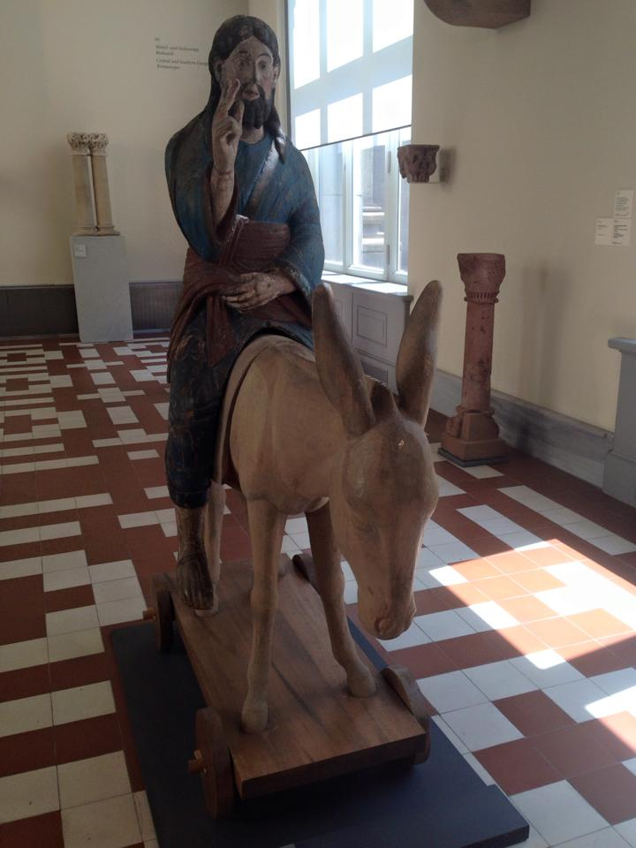
The pageantry of Palm Sunday, can be delightful to a child. Walking in the church’s parade and waving palms high. Palm Sunday – it is also the hopeful opportunity, we often know that spring is just around the corner, and the birds are returning; we seem to get so caught up in the pageantry that we allow ourselves to forget of what will happen later in the week in the Passion Narrative.

This year, the pageantry doesn’t feel as though it is as close to home. It feels as though it is a little bit further away, and we have to be okay with that. Because we know, that we will have Palm Sundays again that are filled with all the aspects of that joy. So instead, this year, let’s contemplate what that pageantry looks like from our homes, our empty sanctuaries, our hearts of community.

We may have to sing Hosanna this year to ourselves, and there are some rousing, and public domain hymns this week, because well because we will celebrate this year – in our hearts, and remind ourselves that we will move forward. Celebrate the lives lived, the gains made, and the possibilities yet to be determined.

Hymns
Hosanna, Loud Hosanna, VU 123
All Creatures of our God and King, VU 217

A Prayer
God beyond all understanding,
We began in a,
Manger in Bethlehem,
We listened to the
Teaching on the mount,
We now march
Triumphantly into Jerusalem,
In this time,
We lift our palms to the sky,
Reminding ourselves
We are together in community,
Wherever we are.
We sing of possibility of connection,
Wherever we are.
We march in the streets of our hearts,
Wherever we are.
Let us lift high our palms, and sing to our delight in your triumphant return.
Amen.

All Images Used were taken by Jeffrey Dale and Used with Permission.

