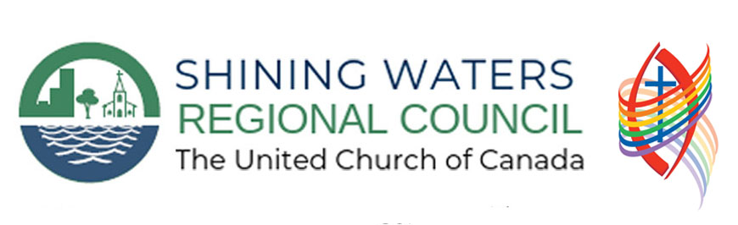
Holy Week
Worship Resources

‘Tis the Gift to Be Simple

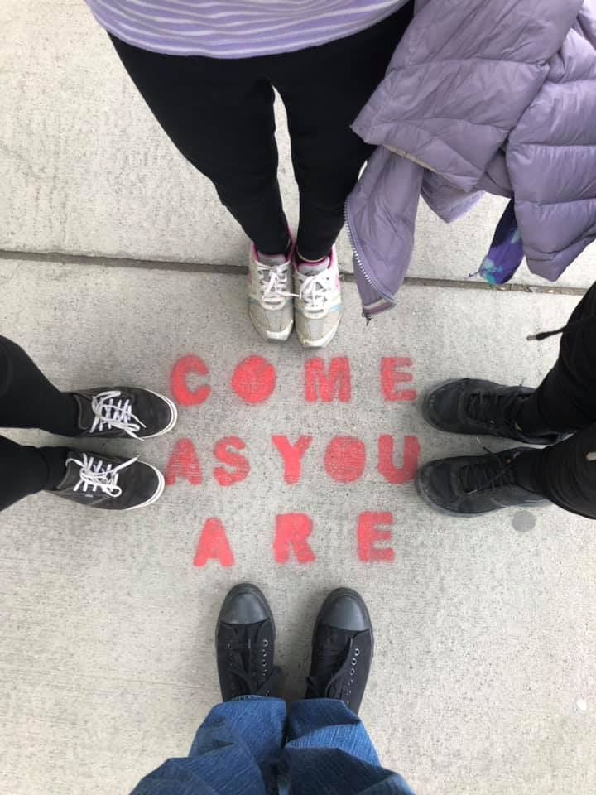
Introduction

The Shaker Hymn, Simple Gifts can be found in Voices United 353, as a printed supplement behind I Danced in the Morning (352) which shares almost an identical tune. As we enter into Holy Week we are preparing for worship that looks very different. How do we celebrate the pageantry of Palm Sunday, the meditativeness of Maundy Thursday, the pain of Good Friday and the joy of Easter when we are watching it all on screens in our homes? It is our hope that these resources will help you to develop some alternative ways of engaging with Holy Week.

For the past few weeks I have found myself listening to Johnny Cash’s Americas Albums. I must admit, I love folk music –Canadian and American. I grew up loving Woody Guthrie, Joni Mitchell, Buffy Sainte-Marie, and Pete Seeger – all often taught to me through various television programs. Inspired by the music of Appalachia, these Holy Week resources draw on this music, but also the music that our hymnals highlight such as: African-American Spirituals,

Using the theme of ‘Tis the Gift to Be Simple these resources are crafted to include as many participants as possible with online worship – while also acknowledging that for some there maybe only a few talking. As always, if something in here helps you, please use or adapt it.

Jeffrey Dale
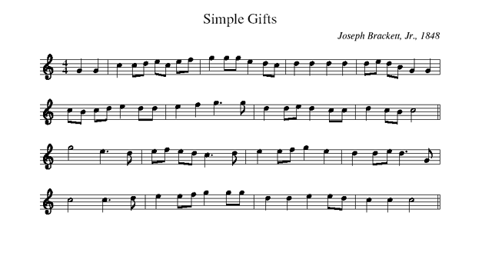
Lyrics
1.’Tis the gift to be simple, ’tis the gift to be free  ’Tis the gift to come down where we ought to be,  And when we find ourselves in the place just right,  ’Twill be in the valley of love and delight.  (refrain) When true simplicity is gained,  To bow and to bend we shan’t be ashamed,  To turn, turn will be our delight,  Till by turning, turning we come ’round right. | 3.The Earth is our mother and the fullness thereof,  Her streets, her slums, as well as stars above.  Salvation is here where we laugh, where we cry,  Where we seek and love, where we live and die.  (refrain) When true liberty is found,  By fear and by hate we will no more be bound.  In love and in light we will find our new birth  And in peace and freedom, redeem the Earth.
2. ‘Tis the gift to be loved and that love to return,  'Tis the gift to be taught and a richer gift to learn,  And when we expect of others what we try to live each day,  Then we'll all live together and we'll all learn to say,  (refrain) When true simplicity is gained,  To bow and to bend we shan’t be ashamed,  To turn, turn will be our delight,  Till by turning, turning we come ’round right. | 4. ‘Tis the gift to be loving, tis the best gift of all  Like a quiet rain it blesses where it falls  And with it we will truly believe  ‘Tis better to give than it is to receive.  (refrain) When true simplicity is gained,  To bow and to bend we shan’t be ashamed,  To turn, turn will be our delight,  Till by turning, turning we come ’round right.

God, healer in the wilderness of life,
Open the minds closed by fear,
grant the willing mind freedom.
God, educator in the temples of life,
Open the hearts closed by anxiety,
grant the voluntary heart enthusiasm.
During this great time of uncertainty and anxiety,
Teach us to be more open to knowledge and understanding,
Teach us to be more aware of others around us and their needs,
Teach us to be more compassionate to the realities facing the world.
And help us, Creator, to stand side by side,
help us, Alpha and Omega, to recognize the beginning and the end,
help us, Gaia, to be in full relationship with all those affected by COVID-19.
Amen

Palm Sunday: You Are Holy

Introduction

Below is a worship service that includes all the pageantry of Palm Sunday but from the comfort of your own homes. You will notice that during the drama part there are speaking parts, encourage members of the congregation to speak these when it is their turn – this works especially well if you are using the platform of Zoom.

We have used the hymn, You are Holy throughout the pageant. This hymn comes from the Zulu tradition in South Africa. In More Voices it states “the Zulu text means “Go/Walk/Travel with us, our liberator… The English paraphrase attempts to capture the journey essence of the original text while expanding upon the notion of God as “Liberator.”” We remind ourselves that Palm Sunday is the celebration of liberation. We get caught up in the pageantry of Palm Sunday as we journey into Jerusalem with Jesus, and at times feel as though we too are on the back of the donkey with him.

During a time of public health crisis, such as the one we are in, it can feel very difficult to celebrate – especially as we recognize that the number of people who are coping with the realities of living with COVID-19/Coronavirus continues to rise not only in our country, but also throughout the world. We must though, remind ourselves of that story from Jerusalem that is over 2,000 years old. The people in the story truly believed in the liberating spirit of Jesus, and we must look in our world for the liberators in our midst: doctors, nurses, hospital staff and scientists who are working very hard to ensure we are helped, as many of us as possible are healed, and that we will live again in a world where we can join together hand with hand.

What People Will Need As They Worship
- The palm branch template, in the resource section. There are parts during the service where they are encouraged to wave their branches.

Hymnals Used
More Voices, You Are Holy (45)

Call to Worship

One: We come yearning for the pageantry.
All: We come to celebrate together.
One: Feeling distant
All: We know we are together!
One: Singing Hosanna!
All: We wave our palms!
(Wave your palm branches.)
One: Let’s join in the parade!

Opening Prayer
God,
when we feel isolated and lack a sense of certainty,
we feel as though we can respond through your spirit.
We are working to build new relationship,
new ways of understanding how to be family together.
We know we are part of the great kindom,
that spreads both far and wide.
We will wave our arms as high as possible,
Our palms will bring us shelter in the times of need,
And be a beacon of our hope in the shining sun.

Scripture Sentences

Isaiah 50: 4a
The Creator God has given me the tongue of a teacher,
that I may know how to sustain the weary with a word.

Psalm 118: 19-20, 22
Open to me the gates of righteousness that I may enter through them,
and give thanks to YHWH.
This is the gate of YHWH, the righteous shall enter through it.

The stone that the builders rejected has become the chief cornerstone.

Scripture Reading
Matthew 21:1-11; Matthew 26:14-27:66 (27:11-54)

An Intergenerational Paraphrase

Jesus was being talked about all over Jerusalem!
“He is coming!” Someone would shout in the market place.
“Have you heard? Jesus, the one they call the Messiah is coming here!”
Another would say to her friend. And it happened, just as they said it would. Jesus and his disciples, his friends that learned from him how to follow the way he was instructing, began walking towards Jerusalem. Many people were expecting Jesus to be like the leaders in the city. Some dreamed of a man who would come in on a white steed and he would save the people from the Roman Empire. Others imagined he would look even more like a God they had heard about from the Chief Priests.
When Jesus and his disciples reached Bethphage, which is at the Mount of Olives, just outside of Jerusalem, Jesus looked at two of his disciples and said,
“In the village in front of us, you are going to find a donkey and her baby, a little colt, bring them back to me.”
Jesus’ disciples didn’t like to take what didn’t belong to them, and they were scared someone would get them in trouble. As they stood there worried about what Jesus was asking, Jesus said,
“If anyone asks you about what you are doing say, ‘Jesus, the Messiah needs them.’”
Jesus’ disciples knew he was the Messiah so they ran off to the village and brought back the donkey and her colt.
Jesus and his disciples continued on to Jerusalem and as they were getting closer to the gates they started to see a crowd of people coming out to greet them! People waving palm braches (wave your palms!) and shouting loudly, “Hosanna! Hosanna! To the Son of David!”
Jesus caused a real stir that day in Jerusalem. In every corner of the city you could hear people whispering,
“Who is this guy that everyone is so excited about?”
“Is that who they say is the Messiah? What’s his name? Jesus from Nazareth in Galilee?”
Judas Iscariot, one of Jesus’ disciples, snuck off and went to the Chief Priests and he said to them, “What will you give me if I tell you who Jesus is?” The Chief Priests looked at Judas, they didn’t trust him, but he was their only hope to capture Jesus, so they said, “We will give you thirty pieces of silver!” Judas decided that he wanted the silver so he would find a time to tell them who Jesus was.

Monologues Dramatic Presentation:
‘An Unknown’s Parade’ and Hymn: You Are Holy, MV 45

NOTE: Send the four monologues to members before the worship. If you are using Zoom, they will be able to know when they speak. During the singing of You Are Holy, encourage people to wave their palm branches – especially if they are on mute.

Disciple:
He said to go get a donkey. A donkey?!? What is he thinking now? He wants to enter into Jerusalem on a donkey? People were stopping us all along the way saying, “Is Jesus coming?!” and “Is the Messiah there?” These people are actually excited to see him! I can’t believe it. Here we are, all these years, we are entering into THE Jerusalem and the people want to actually see JESUS. They really want to see HIM! I can’t believe it?!? I really can’t believe it!?! How does this even happen?! Here goes nothing! Maybe if I just grab the donkey quick enough and run, no one will notice!? Right!? Sometimes, I wonder, does Jesus really know the situations he’s putting us into? Why can’t he just walk right through the gates? Okay. Here goes nothing.

SONG You Are Holy, MV 45

You are holy, you show us the way,
You are holy, you show us the way,
You are holy, you show us the way,
You show us, you show us, you show us the way.
You show us, you show us, you show us the way.

Owner of the Donkey:
The Messiah needs my donkey. Pfft. That’s what I heard today. The Messiah needs my donkey. If this Messiah is so great why does he need my donkey? I ask you this… My donkey.. Pfft… Yes, there are people running out the gates of the city to greet him. Yes there are people jumping up and down, shouting “He’s here! He’s here!” but I don’t see it. If you ask me this Messiah is a bit of a mess. The man can’t even afford his own donkey. If you ask me, and I know no one is, but I’m going to say it, he’s better off just walking through the gate like a normal person because once he’s in here – none of us are going to pay attention to him. I bet after today, no one will even remember his name. And I better get my donkey back.

SONG You Are Holy, MV 45

You are holy, you show us the way,
You are holy, you show us the way,
You are holy, you show us the way,
You show us, you show us, you show us the way.
You show us, you show us, you show us the way.

Roman Soldier:
Usually it is very quiet over on this side of the wall. Especially with the great festival happening at the main gate, but today all these people are running everywhere. So excited, about what? I don’t know. Now they’re just tearing branches off the trees… They’re waving the branches around like wild people. Is there a fire? Are they trying to put out a fire? Should I tell the chief? Who’s that guy on that donkey? They’re all just throwing their coats down on the ground and letting that donkey and guy walk all over them. These people don’t have much. They might be the ones serving at the festivals, but they sure aren’t at the tables. I don’t know what this guy would want with them. They probably will ignore him tomorrow and go back to begging for food, scrounging around somewhere for a cup of water or wine. And yet, look at them all. What are they shouting? (Listens) Hosanna. Hosanna to who?! To this guy on a donkey? Odd behaviour today, that’s for sure.

SONG You Are Holy, MV 45

You are holy, you show us the way,
You are holy, you show us the way,
You are holy, you show us the way,
You show us, you show us, you show us the way.
You show us, you show us, you show us the way.

Child in the Crowd:
I just saw people running, so I followed. I didn’t know where I was going or who I was going to go and see, but I saw people running, and so, I followed. He was up so high on that little donkey and everyone was waving the branches in the air. They were just all so excited to see him. I squeezed past the adults and just as he passed, he smiled at me. I had never seen a king up close. I imagined they’d look different, but he smiled at me. He actually smiled, and I called out to him, “Hey! Mister King! Hey!” And he waved back. I couldn’t hear what he was saying to the crowd, because everyone was shouting “Hosanna!” They were all just so loud. Instead I just watched him as he passed. Everyone ran inside the gate after him. I didn’t. I decided to go and sit under the palm tree that still had some palms left. I don’t know who that man is, but he must be awfully important to have that many people love him.

SONG You Are Holy, MV 45

You are holy, you show us the way,
You are holy, you show us the way,
You are holy, you show us the way,
You show us, you show us, you show us the way.
You show us, you show us, you show us the way.

Moment for Reflection

Consider having a musician play either a hymn or a folk song.
Suggestions: All Glory, Laud and Honour (VU 122), Hosanna, Loud Hosanna (VU 123), or This Land Is Your Land

Time for Community

If you are using Zoom: you can encourage people to share their joys and their sorrows at this time on Zoom by either physically raising their hands or virtually doing so. If you have a large group of people you can encourage them to share their joys and concerns in the chat feature and have one person reading them out to the community, this may lead you into a time of prayer.

Closing Prayer and Benediction

Creator,
We are grateful that in Jesus we are able to witness a life filled with possibility.
He came to us both as a teacher and servant,
As a teacher he taught us to love more deeply,
As a servant he taught us to provide for others without question,
Through him and through the many gifts we’ve received,
Even in this time of isolation, we are reminded,
We are not alone. Thanks be to god.
Amen

As we go about our way in the world, may we go serving one another more graciously, teaching one another more ardently, and loving one another with all our hearts – at a distance –for we know no matter where we are in life, we are always held in the loving embrace of God and community. Amen.

Maundy Thursday: Balm In Gilead

Introduction

For many of us, Maundy Thursday is the night of reflection. We engage in the ritual of the washing of the feet, and prepare ourselves for the coming day of Good Friday, as Jesus is lead to his crucifixion. The worship resources for Maundy Thursday are inspired by the spiritual ‘There is a Balm in Gilead’ which is hymn 612 in Voices United.

The first appearance of the balm of Gilead is in Jeremiah 8:22, where it is written, “Is there no balm in Gilead? Is there no physician there? Why then has the health of my people not been attended to?” There have come many times over the past weeks, and will come many times over the future weeks and months, that we will question decisions made, paths not followed, and possibilities of what can be lifted out of our time with COVID-19/Coronavirus. We will spend time wondering about the health of those around us and why it was not attended to more? Even while knowing the systematic issues that are facing medical and public health professionals.

We then must ask ourselves, what is our part in all of this? How can we educate, engage and enlighten on this Maundy Thursday, and during this time? Think on the possibilities of the future, the chance to grow from this experience and reflect on all we are learning about our bodies and our health. As the lyrics of the spiritual suggests, “Sometimes I feel discouraged, and think my work's in vain, but then the Holy Spirit revives my soul again.”

What People Will Need As They Worship
- A bowl of water and washcloth.

Hymnals Used:
- Voices United, 612 There Is A Balm In Gilead
- More Voices, 18 Lord Prepare Me

Opening Prayer
God, we know that,

In a community of love,
we need not be seated at the same table,
we need not drink from the same cup,
nor eat from the same loaf of bread.

In a community of love,
we need not to wash one another’s feet,
we need not to hug and hold one another,
nor do we need to read from the same book.

In a community of love,
we need to know that we are held in hearts,
we need to know that we are seen as important,
and called on in the time we are needed.

In a community of love,
we need to know that our presence is felt at a distance,
we need to know that our voices matter to the song,
and that our prayers are lifted up as one.

Amen

Hymn
Lord, Prepare Me to Be a Sanctuary, 18 MV

(English) Lord, prepare me to be a Sanctuary,
Pure and holy tried and true;
With thanksgiving,
I’ll be a living sanctuary for you.

(Hebrew) V’asu li mikdash
V’shachanti b’tocham

Va-anachnu n’varech
Yah Me-ata v’ad olam!

Scripture Senteces
Psalms 116: 12 – 17

What shall I return to God,
For all the generous gifts I have been given?
I will lift up the cup, the cup of God’s salvation,
And I will call on the name of the one who created me.
I will pay in my vows to the Creator,
Insight and presence of all God’s people.
Precious are God’s people in the sight,
And in the passing from this world the faithful ones continue.
O God, I am your servant:
I am your servant, the child of your serving girl.
You have loosened my bonds.
I will offer you a song of thanksgiving,
And call in the name of the Creator.

Hymn/Solo Song
There Is A Balm In Gilead, VU 612

Scripture Reading
John 13:1-17, 31b-35

Hand Washing: Alternative to Feet Washing

Several years ago, I worked with a minister who would do handwashing on Maundy Thursday rather than feet washing. She explained that in this modern day and age our hands are often the dirtiest part of our body, and especially in places like Canada where we only wear sandals for a few months a year.
This year, handwashing has been highlighted as the most effective way to stop the spread of coronavirus. As you worship online, encourage members of your community to wash their hands this Maundy Thursday saying to themselves: “You are beloved, because of who you’ve been. You are beloved, because of who you are. You are beloved, because of who you will be.”
After everyone has washed their hands as a community, invite them to sing Lord, Prepare Me to Be a Sanctuary again as a meditative practice.

Hymn
Lord, Prepare Me to Be a Sanctuary, 18 MV

(English) Lord, prepare me to be a Sanctuary,
Pure and holy tried and true;
With thanksgiving,
I’ll be a living sanctuary for you.

(Hebrew) V’asu li mikdash
V’shachanti b’tocham
Va-anachnu n’varech
Yah Me-ata v’ad olam!

Closing Prayer

We have gathered in community,
we have shared in ritual and in recognition,
we go out into the world,
prepared for what will come,
for we know how the story continues,
preparing for what might come in our lives,
for we do not know how the story continues.
But, we know this,
we are loved,
we are nurtured,
we are respected,
In all we do, and in all we need to do,
we are not alone.
Thanks be to God.
Amen

Good Friday: A Wayfarin’ Stranger

Introduction

I will begin by confessing that this worship service was all inspired by the American folk song, A Wayfarin’ Stranger. Recently, I’ve started listening to a lot more Johnny Cash and I have fallen in love with his American Songbook CDs, and one of the songs he sings is A Wayfarin’ Stranger. This song has had me considering Good Friday a great deal. Each year it seems as though we are preparing ourselves more and more for this day, in Barrie there has been a Good Friday walk hosted by the local Kairos, and it is tough to think about how something that has become a fixture in the local community isn’t a possibility this Easter.

As I think of the journey out of the garden, into the engagement with Pilate and the crowds, up to Golgotha, The Place of the Skull, I think of Jesus’ own processing, maybe he saw it much like the writer of the folk song, “I’m just going home.” We know that in the lectionary scriptures for Good Friday, Jesus states, “It is finished,” and so we must remind ourselves of the reality that Jesus is now seeing the end of his time on earth.

As many of us have now spent weeks at home, we must feel as though we are starting to want to run out the door, but we know we must stay home in order to flatten the curve ahead of us. COVID-19/Coronavirus has taught us a great deal about patience, but it has also taught us a great deal of sacrifice. We know there are people out there in grocery stores, hospitals, restaurants, and other service centres sacrificing their own safety so that we may

What People Will Need As They Worship
- No additional resources needed

Hymnals Used:
- Voices United, 144 Were You There?

Prayer

Great Creator of the Cosmos,
you who formed the heavens and the earth,
you who brought breath to the smallest of the small and the largest of the large,
be with us as we embrace the cloth of sadness.
Great Creator of the Mind,
you who formed the writers of people,
you who brought breath to the notions of relativity and wellness,
be with us as we embrace the weave of sorrow.
Great Creator of the Heart,
you who formed the emotions of creation,
you who brought breath to the pain of the realities that we are facing,
be with us as we embrace the fabric of dysphoria.

For we know, Creator,
we walk to the top of the hill,
not alone, but with Jesus, as he prepares, and we prepare,
for all that lays before us.

Amen.

Scripture Sentences
Psalm 22: 1-5
My god, my God, why have you forsaken me?
Why are you so far from helping me, from the words of my groaning?
O my God, I cry by day, but you do not answer;
and by night, but find no rest.
Yet you are holy,
enthroned on the praises of Israel.
In your ancestors trusted;
they trusted, and you delivered them.
To you they cried, and were saved;
in you they trusted, and were not put to shame.

Isaiah 52: 6,7a,8
All we like sheep have gone astray
we have all tuned to our own way,
And in Creator has laid on him
in iniquity of us all.
He was oppressed, and he was afflicted,
yet he did not open his mouth;
By a perversion of justice he was taken away.
Who could have imagined his future?

Hymn
Were You There, VU 144

Scripture
John 18: 1-19:42

A Consideration
As we recognize the growing numbers of people who have succumbed to COVID-19/Coronavirus, Good Friday is a time for us to understand our relationship with lives lost due to this public pandemic. It may be that Good Friday is the time for a litany to be read where we consider those who are working hard to provide healing at this time, while recognizing the lives lost. Prepare a litany that maybe can be shared by members that are present on the call. Remind yourself to include such people as:

Public Health:
Hospitals, nursing homes, and other health care facilities
The World Health Organization
Medical researchers, scientists, and those working to produce testing kits

School Systems:
The students that are left out of class, wondering
Teachers that are learning how to navigate new systems of learning.
Administrators, making tough choices

Work places:
Workers who are now being laid off, and worried about the costs of living
Workers who are anxious about safety of going to work where the building is not closed. People working in high risk spaces, for minimum wages such as grocery stores.

Government Institutions and Municipal Agencies:
Guidance in decision-making
Hope in the possibility that the right people will receive the funds needed

Those Living on the Margins:
People in shelters, who are unable to stay in spaces of warmth
Foodbanks, where they are working to support those in need
Elderly, that are experiencing a new form of social isolation
People living with Mental Health Wellness struggles or illness, as they lack programs, and community engagement.
The underpaid and the now-unemployed workers who are living paycheque to paycheque.

A Closing Prayer

God of deep fear and anxiety,
be with us as we prepare to enter into a time of uncertainty,
we know that Jesus lived, and in that life there was hope, and now Jesus is gone,
and it may seem as though our hope is gone too.

God, we are living in a time of deep shadows of puzzlement,
may we listen to those who are providing us with information,
let us support more the people who need help,
and know that the only way through the fear is together.

Amen

Invite a member of the congregation to sing ‘Wayfarin’ Stranger’ as you leave the Zoom call in silence.
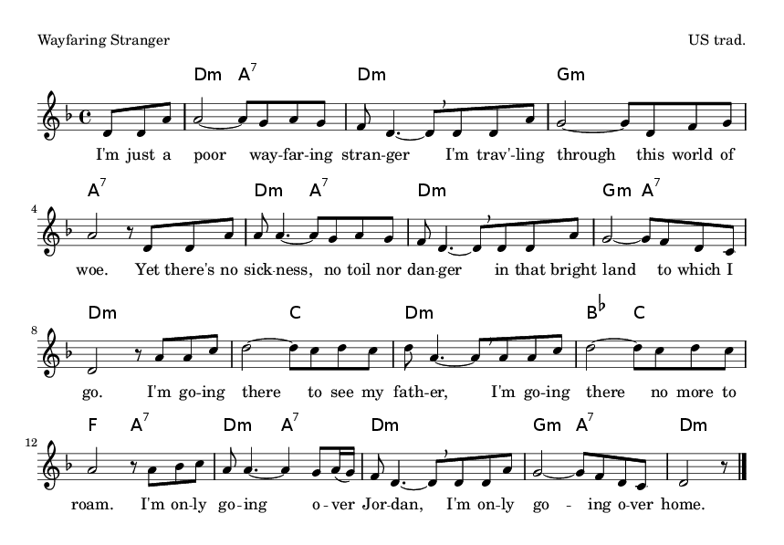
2. I know dark clouds will gather ‘round me,  I know my way is rough and steep,  Yet golden fields lie just before me  Where God’s redeemed shall ever sleep.  I’m going there to see my father  He said he’d meet me when I come.  I’m only going over Jordan.  I’m only going over home. | 3. I want to wear a crown of glory,  When I get home to that good land.  I want to shout salvation’s story,  In concert with the blood-washed band.  I’m going there to meet my Savouir,  To sing his praise forever more.  I’m just a-going over Jordan.  I’m just a-going over home.

Easter Sunday: I Danced

Introduction

Easter Sunday will be difficult. There is no way around it this year, we are missing out on the opportunity to be in community in person. But, at the same time remind ourselves – we are still in community. We have an opportunity to know one another in this new way.

It has been a few weeks now we have been trying to figure out what online worship looks like, and we are working towards a new normal. So let’s have fun. This week we have noise makers to help us celebrate what we have learned due to COVID-19/Coronavirus, and we are learning how to be community in a new way.

We have taken the Shaker Tune, Simple Gifts, and put it into I Danced in the Morning this Sunday as we remind ourselves of the opportunity that has been presented to us as we worship in our homes – we have a chance to showcase what matters to us – that we are present in community, wherever and whenever possible.

What People Will Need As They Worship
- Noise Makers!
- People’s own grape juice and bread (or their substitute)

Hymnals Used
Voices United, I Danced In The Morning, Crown Him with Many Crowns (211)

Call To Worship & Opening Prayer

One: Christ Has Risen!
All: He Has Risen, indeed!
One: Christ Has Risen!
All: He Has Risen, Indeed!

One: Indeed, Christ has risen,
And with Christ we rise in hope –
hope of the future,
hope of possibilities,
hope of a lift ahead.

O great eternal spirit, earth-maker, pain-bearer, life-giver,
Be with us in the moment of resurrection, where all things seem possible, where all hope seems probable. We have come from a place of anxiety and fear and out into the light of hope. We dance this day knowing that we are working as hard as possible to bring about systematic changes in our world. The empty tomb has taught us that we all have a part to play, we all have the potential to change the narrative, and we all are integral to understanding through concerning the health of community, we are following the way of justice, and now we dance!

Hymn
I Danced in the Morning, VU 352

Scripture Sentences
Acts 10: 36 – 41
You know the message God sent to the people of Israel, announcing the good news of peace through Jesus Christ, who is Lord of all. You know what has happened throughout the province of Judea, beginning in Galilee after the baptism that John preached— how God anointed Jesus of Nazareth with the Holy Spirit and power, and how he went around doing good and healing all who were under the power of the devil, because God was with him.
“We are witnesses of everything he did in the country of the Jews and in Jerusalem. They killed him by hanging him on a cross, but God raised him from the dead on the third day and caused him to be seen. He was not seen by all the people, but by witnesses whom God had already chosen—by us who ate and drank with him after he rose from the dead.

A Time for Family – Make a Little Noise
Note: if you are on Zoom you will need to unmute everyone at the right moment.

We’ve encouraged people to make noise makers have them ready for this part of the worship service. Being with:

One: Christ has risen!
All: He has risen, indeed!

Continue, on this Easter Sunday we can’t egg hunt in the church, although I do hope many of you have already done so at home. Instead, we are going to make noise! Throughout the COVID-19/Coronavirus time at home people have been encouraged at 7:30 pm each night to go out onto their front porch and make noise in support of all the healthcare workers that are putting their own lives on the line. Since we are not worshiping at 7:30 pm, we are inviting you to make some noise together today in support of all the front line workers in places of healthcare, all the workers in public health, and also all those who are risking their lives in other ways, such as grocery stores and other retail positions. So after we say, he has risen indeed, let’s make some noise:

One: Christ has risen!
All: He has risen, indeed!

Scripture
Matthew 28:1-10

Hymn
Crown Him with Many Crowns, VU 211

An Easter Litany
Formed in the womb of his mother,
and born in the most unlikely of conditions.
He came preaching the stories of peace,
and taught us to believe in the least amongst us,
to lift up the marginalized,
to understand the poor in spirit,
to recognize the needs of others.
That creed, religion, race, gender, orientation,
are to be lifted up through the spirit of community,
as celebratory aspects of life!
He rode into Jerusalem on that faithful day,
with the waving of palm branches to welcome him,
with shouts of Hosanna.
He spoke out against the injustice in the marketplace,
he saw the forms of capitalism for what they were,
greed and power over person and spirit.
He encouraged his disciples,
the believers of his message,
to take up the bread and break,
a sign of his love for them.
He encouraged his disciples,
the believers of his message,
to take up the cup and drink,
a sign of his blessing set down upon them.
And that night,
he was taken away, by a kiss and sword,
he exclaimed to not live by the sword,
for you will perish by it if you do.
Instead, he went before trial and was punished to death,
there on the cross he met his death,
but at daybreak,
he was not there, he had been resurrected,
and from the womb at birth,
to the tomb at death.
We are reminded,
we are a resurrection people,
we are blessed,
we are one, even when we are a part,
we are an Easter people.
Let us rise,
shouting Alleluia!
once more.

An Online Communion

Anything can be the elements of communion this Easter Sunday. If you are to engage in a sacrament of communion allow those in your community to know that the bread they break maybe a cracker, muffin or bread. They may use their morning tea or water as the cup of blessing at this time. Remind your community of faith that this Sunday their table at home is also Christ’s table. Invite each person to go to the table where their elements are present, allow for the time for this to happen, maybe have reflective music playing.
Invitation

Welcome to tables that are spread out across our community,
some of you will be sitting the family’s antique table,
some of you maybe sitting in your comfy chair with your lap as your table.
Know that wherever you are this Sunday,
you are at Christ’s table.
For Christ is in your heart,
and your house.

Prayer

God, sustainer of us all,
in our moments of deep fears, we praise and thank you,
that through the creating spirit of this earth, and through your word,
we are welcomed at this table in prayer, praise and thanksgiving.
For the goodness of the earth, the space of creation,
in the glory of redemptive powers,
we praise your unending dancing spirit.
Invite us now, the call of your prophets,
enlighten us, with the knowledge of your disciples,
and bring us unto the place of understanding with all in our community.

As we see that which is unseen,
as we remind ourselves of our faithful journey,
in this time of thanksgiving and praise.
Amen

Prayer of Consecration (from ‘Celebrate God’s Presence, pg. 263)

On the last night he spent with his friends,
Jesus took an age-old tradition of his people
and transformed it into something new.
He took bread, staple food of his land,
blessed and broke it, and gave it to those around him saying,
“Take, eat, this is my body, broken for you.
Whenever you do this, remember me.”
After supper he took a cup of wine, common drink of his people,
and gave it to them, saying,
“Drink this, all of you, this is the new covenant in my blood.
Each time you do this, remember me.”
By remembering Jesus in this way now,
we claim our common heritage
as we proclaim the mystery of faith:

Christ has died. Christ has risen. Christ will come again.

Send, O covenant God, your Holy Spirit
upon us and what we do here,
that we and these gifts, empowered by your Spirit,
may become signs of shalom
to one another and to all peoples of the earth.

Through Christ, with Christ, and in Christ,
in the unity of the Holy Spirit,
all glory is yours everywhere, now and forever.

Amen.

Sharing of the Elements

Leader: I invite you now to pick up the bread of belonging, may we as community share in this feast, together.

Leader: I invite you now to pick up the cup of blessing, may we as community share in this feast, together.

Prayer of Thanksgiving

God of great wisdom and love,
You know that Christ’s enduring love is not limited by walls,
you have taught us that we may be in community even when we cannot touch flesh to flesh.
God of infinite time and space,
Let us not be bound by the understandings that we have put in place in our lives,
instead may we remind ourselves that your great creation is how we must commune on a daily basis.
May we build right relationships with all our relations,
even in the midst of the pandemic we are facing,
may the bread of belonging sustain us,
may the cup of blessing nourish us,
and may we work to find refugee in the healing spirit that moves amongst us.
Amen.

Closing Benediction

We have come together to worship and we take with us the community that we find in worship. I invite you into the benediction written by Rev. Dr. Cliff Elliott, who was a minister in The United Church of Canada, who stated, “Go forth into the world with a daring and tender love, go in peace – the world is waiting. And whatever you do, do it for love, and in the spirit of Jesus – who is your Christ! Amen.”

Create a Worship Space at Home

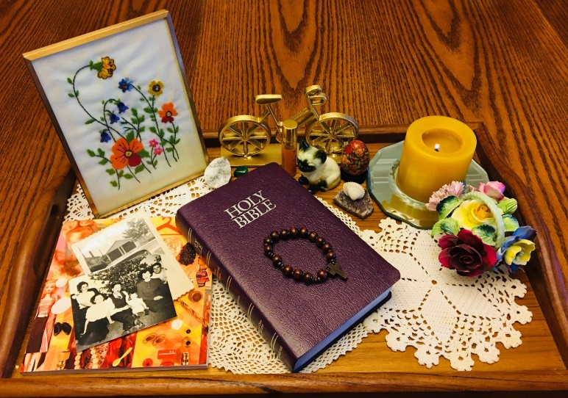
As we look ahead to another Sunday worshiping at home, I invite you to take a few minutes in the next couple of days to create a space for worship. God is always present with us, but we all have places and things that remind us more clearly of the sacred. You are welcome to do this any way you wish, but here is one possibility:
First, think about where in your home you feel most aware of the sacred. If you will be using something portable, like a laptop, tablet, or phone, then you can choose anywhere in your home. Does the warmth of the kitchen connect you to God’s Table? Does a view of a garden, or a place you can hear birds remind you of the divine in creation? Does a corner of your bedroom bring you a feeling of peace?

If you have a desktop your location is already decided, but you can still think about how to create a worshipful space around the desktop – could you bring in an item that connects you to the divine – a teapot, a flower, a knit blanket, or anything else that reminds you of your favourite place at home.

Next, set up your worship space. Choose a few simple items and clear everything else away, so that it doesn’t intrude on your time of worship. Choose anything that feels right to you – you might consider some or all of these:
- a comfortable place to sit
- a candle and matches
- a picture or pictures that connect you to the sacred (such as stained glass, nature, people you care about, or something else meaningful to you)
- something that connects you with offering
(if you give using envelopes or loose cash, consider creating a Leaside envelope that you can add to each week and then bring in when we’re worshiping in the building again. And everyone might consider something that connects you with other ways that you give your time and talents for the sake of the world)
- if you like reflecting through writing or drawing, you may want to add a journal or notepad and pen
- if you like to read scripture from your Bible, or if you have hymn books at home, you might add these too. We’ll also share links in the service.

Is your home too small to keep a worship space set up all week, or even all day? Consider creating a worship-space-in-a-box that you can take out when you are ready to worship.
Finally, take a moment to appreciate the space, with a prayer, blessing, or deep breath to connect you to the sacred all around us.

Rev. Emily Gordon, Leaside United Church

