Resource for Living Faith Stories
Ask the why question
Why do we gather as a community of faith?
Why am I a participant in the life and ministry of this community of faith?
Why does God’s mission need our community of faith?

What is a Living Faith Story?
Living Faith Story
The living faith story articulates the community of faith’s ministry focus. The living faith story is your opportunity to share why you exist as a community of faith. All communities of faith are expected to develop a living faith story, review it regularly, and share it with the regional council so that support can be programmed. The living faith story is an opportunity to tell a story about where God is leading the community of faith.

While the Living Faith Story serves a purpose in the relationship with the denomination in terms of pastoral relations and community of faith support, it is intended to be more than an exercise in compliance. The creation of a Living Faith Story is an invitation for your community of faith to engage intentionally a conversation about ministry and mission.

The living faith story can be narrative—or it could be an audio or video recording of the community of faith telling their story.
It is hoped that this stage of the pastoral relations process will not be onerous. The community of faith may use one of the following as their living faith story:
• A recent Joint Needs Assessment Committee (JNAC) report may only need slight modification to tell the community’s story.
• A recent ministry profile, list of mission and ministry priorities, living ministry profile, ministry articulation profile, or essence statement from an Effective Leadership and Healthy Pastoral Relationships project in your former Conference may need only slight modification.
• If your community of faith has recently participated in a visioning exercise with EDGE, you could use your ministry goals, vision statement, and current realities articulated in that work.
• A narrative budget and other applicable material (that names your ministry both within and beyond the community of faith) from the Called to Be the Church giving program (www.stewardshiptoolkit.ca) could be suitable.
• Use an existing vision or long-range planning document.
• Finally, of course, you can develop a unique, original living faith story, which articulates the ministry of your community of faith.

From the Pastoral Relations Handbook for Communities of Faith

Why are we being asked to create a Living Faith Story?
The creation of a Living Faith Story can be a spiritual practice for the community of faith as it reflects on its ministry, mission and faithful witness to the Gospel. It is an intentional way of engaging communities of faith in articulating their purpose and faith. In a time when the church is dealing with a changing cultural context it provides an opportunity ask questions about how communities of faith understand their particular ministry. Creating a Living Faith Story is an invitation to articulate, assess, and perhaps even reframe how we are being church.

How is a Living Faith Story used?
CHURCHHUB
Your community of faith will receive login information for the ChurchHub. This is a technology data interface that allows updates to your community’s information and is used as a tool for search during the pastoral relations process. It can be reach at www. Churchhub.ca but you cannot login to your particular page without the login information. The Living Faith Story is posted in the Community of Faith Profile link, the first box that will appear in the drop down menu. If you are posting more that text (like a youtube video), you can put links to your material.
- It is a requirement for communities of faith in the pastoral relations process.
- It is part of the covenantal relationship with the Regional Council and part of the self-assessment process with the Regional Council.
- It is posted on ChurchHub as a description of the community of faith.
- It is guide to use by your community of faith in shaping ministry priorities and sharing a vision of your community and mission.
- For those communities of faith in search of a new ministry covenant, this is your invitation to ministry personnel to consider whether they are being called to your ministry context.

Where is it shared?
- It is posted as part of the community of faith profile on ChurchHub.
- The Regional Council accesses the Living Faith Story as a resource for the ongoing work of support and oversight.
- When in pastoral relations search, the Living Faith Story is a required part of the community of faith profile that is posted for ministry personnel in search to view.

Who Prepares the Living Faith Story?
- The Governing Body could do this work or appoint a working group to draft.
- Community of faith could be engaged in the process through consultation
The Living Faith Story is required to be part of the Community of Faith Profile approved by the community of faith in the pastoral relations process. It would be best practice to have the community of faith approve the Living Faith Story whether or not it is in an active pastoral relations process, both as a communication and educational opportunity.

Is there existing material that we might use as our Living Faith Story?
• A community of faith has recently participated in a visioning exercise with EDGE or has completed a Ministry Articulation Profile (MAP). The governing body takes the vision statement developed from that congregation work, with the ministry plan, and uses that as the living faith story.

• A community of faith has recently been using the stewardship resource Called to Be the Church. The governing body decides to submit the narrative budget as their living faith story.

• A community of faith is at their wits’ end. For their living faith story, the governing body writes: “We are a faithful people who love God but have no idea what direction our ministry should be heading.

- The Community of Faith prepared a video presentation for its annual meeting outlining the mission of the community of faith. This could be posted as the Living Faith Story.

What Support is available to help in developing the Living Faith Story?
- This resource.
- Regional Council Pastoral Relations Minister
- Regional Council Liaisons for those communities of faith in the pastoral relations process
- Regional Council Support to Communities of Faith Minister for those communities of faith not in the pastoral relations process developing the Living Faith Story

What is not needed in a Living Faith Story
- Statistical demographical information – this is populated from the annual filing of your statistical forms and is part of the information on the community of faith demographics profile in ChurchHub. This information can be updated when posting the community of faith profile.

Resources for developing a Living Faith Story

Workshop with community of faith or governing body

Opening Prayer:
Ever faithful God, in Christ you call us be the Church,
living in the world, as the fullness of the Body of Christ.
In this time of conversation,
inspire our thinking about our discipleship,
open our hearts to the leading of the Spirit,
and grant us honesty in our reflections.
May we come to cherish our story of witness,
even as a open ourselves to new ways of living that story.
For we come seeking to be faithful followers of Christ. Amen
Introduction Sharing the intent and uses of Living Faith Story
This information is found in this guide.
Exploring the why of our community of faith
Give each person and index card and ask them to write down 3 reasons why they are part of
your community of faith. ( 5 minutes)
Invite people to find 2 others they with whom to have conversation. (Groups of three)
a. Each person share the 3 things they have written on their card. (about 6 – 8 min)
b. As a group, on index cards choose 3 things (write one things on each card so it can be read
from a distance) that you would all agree are important reasons your are part of your faith
community. ( 5 min)
c. Have each group share what the 3 things they have named. Post index cards.
Plenary –
What does this tell us about what is important to us, who we are, and why we gather as a community of faith? Capture this on newsprint. (10 min)
What does this tell us about why God needs our community of faith live its story in this place? (10 min)
This is part of how we are a living story of God’s call to be the church. How might we best share that story? (10 min) Brainstorm communication ideas and mediums – what tools would help you to convey with excitement your story?
Assignment of tasks
Assign a small group to use the information to create the Living Faith Story.

Narrative Example of a Living Faith Story
Example - Living Faith Story

Our story as a community of faith is deeply rooted in the history of our small village. For over a hundred years people have gathered in our church building as a witness to our faith in God and our commitment to being part of the community and our witness to the gospel of justice and love. We believed that we are called by God to live our faith as individuals and as a community of faith with joy.

Our community of faith has a vibrant worship life. Sunday morning worship is an expression of our gratitude to God and our joy in being together as people. We are multigenerational community. If you were to visit us for worship, you would find 50 – 60 of us gathered together. Some of us would be present with three generations of our family; others of us are single seniors worshipping in the same building as when we were children; yet others of us, have recently made our community home to raise our family or to retire. The children and youth, though small in number bring joy and hope to our congregation. We are blessed with musical talent galore, and openness to all musical styles. You can find us singing country gospel and world music from More Voices in the same worship experience.

We have dedicated lay leaders who are intentional about training and inviting others into leadership. For many years our administrative planning and oversight has been done by a Council of about 10 elected people who serve specified terms of office. The Council also holds an annual retreat each Fall to plan for the coming year and to think about priorities. Our minister is called upon to help plan and lead this retreat time.
We wrestle with finding the resources to do all that we might like to do. Our 43 identifiable givers contribute about 75% of our required budget, with the rest being raised through fundraising activities which in a number of instances also serve as community gatherings and team building. We understand ourselves to be part of The United Church of Canada and called to share in the mission work of the Church is world, and so we take seriously our Mission and Service goal each year. The women of the church, though no longer labelled as UCW contribute to the stewardship of M&S and help us to reach our goal of $5000. We know that we have been blessed in many ways and we seek ways to share in being a blessing to others.

In our village there are a number of Christian denominations, and an active ministerial where despite differences, community ecumenical events like the annual Christmas Carol Sing are undertaken and shared. Our congregation has always been an active participant in the ecumenical activities and our minister in the ministerial.

Living our faith in the context of our village is important to us. We undertake two major outreach activities on an ongoing basis. The longest standing of these is the Harmony Club for seniors that gathers once a month in our building, our congregation hosts lunch and a program. There is also a group of drivers that assist in transportation. The program gathers seniors from the entire village and surrounding community. Our second project is the support of the local foodbank which is located in the Anglican Church. We participate with donations of cash, food and active volunteers.

Our community of faith’s living faith story is about believing we make a difference in our community, we know we make a difference in the lives of each other and we are commited to living the calling of Christ to love our neighbour near to us and across the world.

Example of a Storyboard Living Faith Story
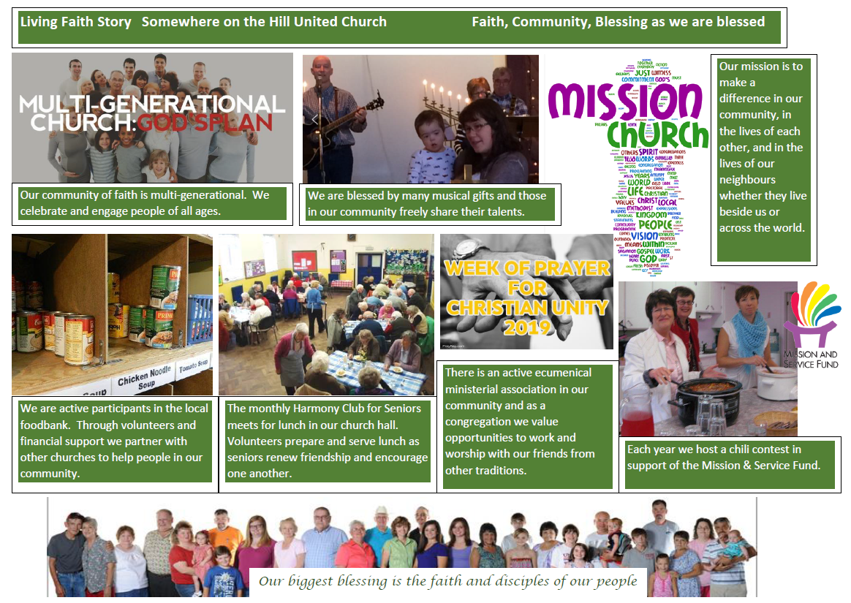

Example of a Video that could be
part of a Living Faith Story
http://www.trinitylively.ca/trinity-trailers

Sample Living Faith Story Template
From the Pastoral Relations Community of Faith Handbook
Don’t feel you have to answer every question in this template! Use the ones that connect with your context and ministry. Please don’t write an dissertation of many pages trying to cover every question!
A community of faith can use the template below to develop their own living faith story. In each category, they can list the activities they are already doing and list any specific goals. If the community of faith does not currently have a goal in a specific category, that’s okay. There are also some guiding questions in each section to help them think about this area of ministry. They do not need to answer all of the questions, just the questions that are helpful to their situation.
The categories in the template are from the Ethical Standards and Standards of Practice for Ministry Personnel (available on www.united-church.ca), which provides clarity on the definition and focus of each category. The ministry personnel profiles in ChurchHub are based on the same categories.
Category Title | Guiding Questions
Administration | List all the activities that currently support administration.  What is your specific goal related to administration? (If you don’t have one at this time, that’s okay.)  How is your work in this area connected to your Christian faith? Why do you do what you do? How is it connected to your witness of the gospel?  What level of administrative support is offered to your community of faith and to your ministry personnel? Is it staff? volunteer?  What kind of information technology infrastructure does your community of faith have and use? Are there expectations around engagement using social media?  What model of governance do you use in your community of faith? (e.g., council, official board, session)  How frequently do you review your financial situation? How would you describe your financial position: healthy? abundant? struggling? near to crisis? other? What is the “story” behind this description? How did you get here?  Describe the human gifts that you have in your midst. What are your strengths? What areas do you need to nurture and grow?  How much of your budget is allocated to administration?
Community Outreach and Social Justice | List all the activities that currently support community outreach and social justice (e.g., soup kitchens, homeless shelters, seniors’ centres, vacation Bible schools, English as a second language training, food bank, Christmas hamper, used glasses donations).  What is your specific goal related to community outreach and social justice? (If you don’t have one at this time, that’s okay.)  How is your work in this area connected to your Christian faith? Why do you do what you do? How is it connected to your witness of the gospel?  How do you understand community outreach and social justice to be part of your community of faith?  How do you identify community needs? Who are the marginalized and vulnerable within your faith community? within your local community?  To what extent do you collaborate with other groups with common goals or interests?  What are the unique needs or strengths or issues facing the community right now? How have you responded?  If someone were to visit your community of faith, how would they know you are involved in community outreach and social justice activities?  How do you think your community of faith is seen in the local community?  Would community members (people not involved in your community of faith) describe you as being involved in specific local or global or community issues? What would those issues be? If you don’t think your community of faith is seen as being involved in local or global community issues, how do you feel about that?  To what extent do you know and use General Council resources about specific justice issues (e.g., climate change, Indigenous justice, intercultural vision, becoming an Affirming congregation)?  How are those who are involved in community outreach and social justice activities supported by others in the community of faith?  How much of your budget is allocated to community outreach and social justice activities?
Denomination and Communities | List all the activities that currently support your denomination and communities (e.g., active in your regional council or General Council, collaborating with local agencies or tenants within your building).  What is your specific goal related to your denomination and communities? (If you don’t have one at this time, that’s okay.)  How is your work in this area connected to your Christian faith? Why do you do what you do? How is it connected to your witness of the gospel?  How is leadership by lay people and ministry personnel exercised in your community of faith? at the regional council or General Council?  How is leadership exercised in your local community? How important is it for your community of faith to be involved with other local leaders (not necessarily within the church) and/or with other faith communities and their leaders?  How does your minister’s ability to develop meaningful partnerships affect your community of faith’s ability to thrive and move toward your mission priorities?  How important is it that your minister is well‐connected with other ministers (has a support network)? with other community leaders outside the church (e.g., social service, ministerial, local politicians)? to the work of the regional council? to General Council activities?  What role do lay people play in developing and nurturing effective ministry partnerships?  Is this a formal team ministry position? If so, what are the relationships among the team members—who reports to whom? Or are the relationships based in co-operation and collaboration?  How do you expect the ministry personnel to work with other non‐ministry paid staff? with lay people?
Faith Formation and Christian Education | List all the activities that currently support faith formation and Christian education growth (e.g., Sunday school, youth group, confirmation classes, seekers’ group, Bible study, prayer circles, seniors’ circles, spiritual practices, activities for families, parents of teens support group).  What is your specific goal related to faith formation and Christian education? (If you don’t have one at this time, that’s okay.)  How is your work in this area connected to your Christian faith? Why do you do what you do? How is it connected to your witness of the gospel? Describe why you think this is important or unimportant.  How are these activities supported by ministry personnel? by lay people?  To what extent do you think these activities are effective? How do you know they are or aren’t?  How important are small groups to supporting people in the formation of their identities as “disciples” and as members of this community of faith?  How much of your budget is allocated to supporting faith formation and Christian education activities?
Leadership | List all the activities that currently support leadership (e.g., lay leadership training, conflict resolution workshops).  What is your specific goal related to leadership? (If you don’t have one at this time, that’s okay.)  How is your work in this area connected to your Christian faith? Why do you do what you do? How is it connected to your witness of the gospel?  Describe the minister whose leadership skills best matched your community of faith’s needs. What was it about their style of leadership that made a good match?  What kind of leadership skills are you looking for in your minister (e.g., strong authoritative leader who sets direction and motivates others to follow; strong consensus‐builder who takes time to include everyone in decision‐making and enables others to participate; an able companion who supports and nurtures)?  Who do you look to for leadership in your community of faith?  How much responsibility for leadership is placed on ministry personnel? on lay leaders?  How does your community of faith support the development of leadership skills in ministry personnel? in lay leaders?  What are the barriers in your community of faith to achieving your goals? Do any areas of leadership need to be developed in order for you to achieve your goals? Are there unacknowledged areas of conflict that prevent you from moving forward? To what extent do you have the skills to address conflict and communication challenges in your community of faith?  How much of your budget do you allocate to leadership development for ministry personnel? for lay leaders? for those who are not currently in leadership but who demonstrate interest and potential abilities?  How do you support lay people to discern their gifts for leadership?
Pastoral Care | List all the activities that currently support pastoral care (e.g., home visitation, caring phone calls, prayer shawl knitting).  What is your specific goal related to pastoral care? (If you don’t have one at this time, that’s okay.)  How is your work in this area connected to your Christian faith? Why do you do what you do? How is it connected to your witness of the gospel?  How do you define pastoral care in your setting?  How much time is spent on pastoral care by your current ministry personnel?  To whom is pastoral care provided? (e.g., members, adherents, community members)  Who (in addition to ministry personnel) provides pastoral care now? What training do they have? To what extent are they supported by the ministry personnel?  Have you identified specific spiritual care needs in your community of faith or local community for which special skills are required? (e.g.. Do you have a special ministry for people struggling with addictions, or do you have a large number of seniors? How important is palliative or end-of-life care? or support for families of children with special needs?)  Is there a team of trained lay people that support the pastoral care of the minister?  How much of your budget is allocated to supporting pastoral care?
Self-care | List all the activities that currently support self-care and spirituality within your community of faith (e.g., healing touch, spiritual practices).  What is your specific goal related to self-care and spirituality within your community of faith? (If you don’t have one at this time, that’s okay.)  How is your work in this area connected to your Christian faith? Why do you do what you do? How is it connected to your witness of the gospel?  How do you support the development of a community of faith identity?  How do you build a sense of community within your community of faith?  How do you love and support one another?  How do you encourage participating members to find a balance (e.g., helping people not to burn out)?  How much time is spent together as a community that isn’t about raising money?  How much do you like each other? How do you have fun together?  How vulnerable and honest are you able to be with each other?  How would you describe the spiritual life of your community of faith?  How does your community of faith support the health and spiritual growth of your minister?  How important is the health and spiritual growth of your minister for the health and spiritual growth of your community of faith?  What do you hope your minister does to support their own health, wellness, and spiritual growth?
Worship | List all the activities that currently support worship (e.g., traditional order of service with hymns, prayers led by one person, 20-minute sermon/reflection, scripture readings; contemporary with shorter sermon, more music, variety of prayer styles; reflective with lots of time for silence and contemplation).  What is your specific goal related to worship within your community of faith? (If you don’t have one at this time, that’s okay.)  How is your work in this area connected to your Christian faith? Why do you do what you do? How is it connected to your witness of the gospel?  Describe the demographic profile of your community of faith at worship. (You may have to describe multiple profiles if your community of faith offers more than one worship opportunity or if you are a multi-point pastoral charge.)  What makes worship inspiring for your community of faith?  What aspects of the worship service are led by the minister? What aspects are often led by lay people?  How do you use technology in worship?  Is music most often accompanied by organ? piano? praise band? no accompaniment?  What types of music are most frequently used? (e.g., classical church music, traditional hymns from Voices United, range of music from both Voices United and More Voices, other contemporary hymns, secular music that lends itself to worship)  Is there a choir? a children’s choir? other musical groups? Are there professional musicians in music leadership?  What type of worship leadership is most frequently used during sermon time? (e.g., sermon delivered by minister, sermon with dialogue, dialogue based on the text, drama)  Prayer: Who usually leads prayer? Do participants offer prayers aloud? in silence? Are there sung prayers? circle prayers? written-down prayer requests?  What translation of the Bible are you most comfortable with?  About sermons: What is meaningful for you in sermons in terms of content, relevance, academic/theoretical/historical components, length?
Worship (continued) | How do you support the ministry personnel to grow in their worship leadership? How do you support lay people to grow in their worship leadership?  How much of your budget is allocated to providing inspiring worship?  How comfortable is your community of faith in experimenting with worship? Give an example of some experiments you’ve tried and what you’ve learned.  How is stewardship kept visible? Who takes responsibility for it now?  How comfortable is your community of faith talking about money?

Manual 2019 References to Profiles and Self-Assessment

